San Vicente Valley Club
San Vicente Valley Club’s Luncheon will be on Wednesday, February 26th at the San Vicente Valley Resort, 24157 San Vicente Road. The luncheon is open to the public; guests are encouraged to make reservations at the front desk or call Maxine McNamara 760-788-6189 by Friday Feb 21th. The cost is $12.00. If a cancelation is necessary please contact Maxine.

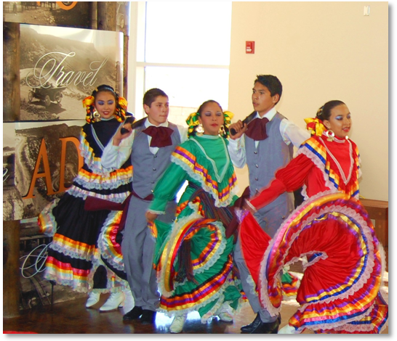

Our speaker Ieda Smith started teaching Mexican Dance in Ramona with 2 children in 1980. In 1999 she had 60 children. Ieda makes several costumes and they have performed at the Del Mar Fair, all Ramona Schools, and Convalescent Homes. Older students help teach younger students all from Ramona schools. They know many different regional Mexican dances.

The order of events for the day will be: Check-in and Social time 11:00

Call to order 11:30

Luncheon 12:00

Program 1:00

We are a nonprofit organization for all residents of Ramona brought together for the social, philanthropic and civic betterment of the community with our generous charitable contributions towards student scholarships and the needs of our community. For membership information please contact:

Maxine McNamara 760-788-6189.

